Write a mapreduce job that takes configuration from command line (min.word.count). Based on the configuration, it should perform count of words from a document and produce only those words in the output whose count is greater than or equal to the configuration.

**DRIVER CLASS:**

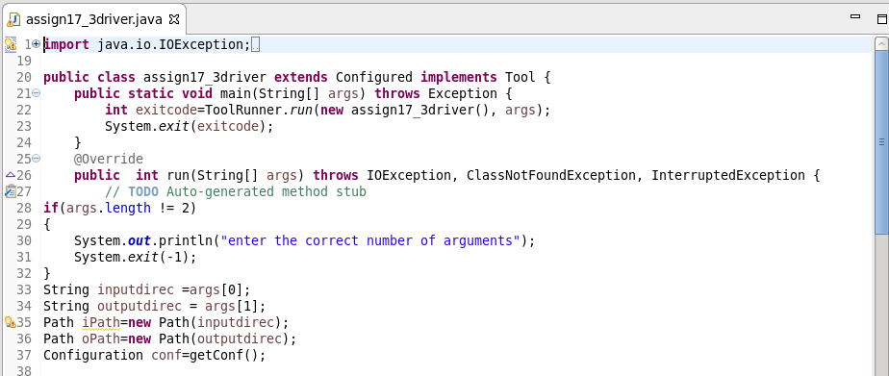

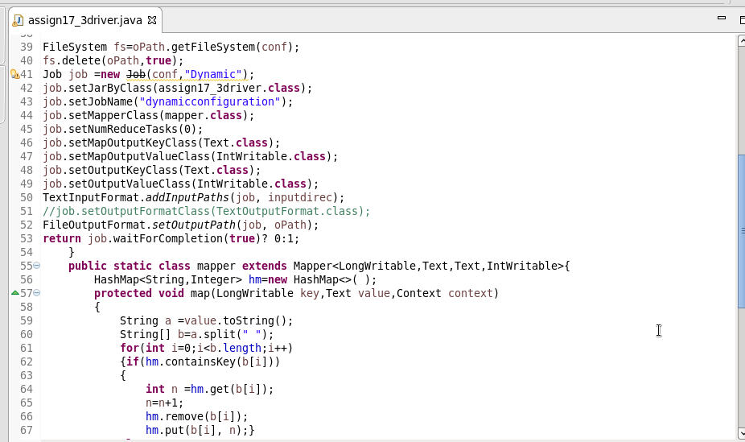

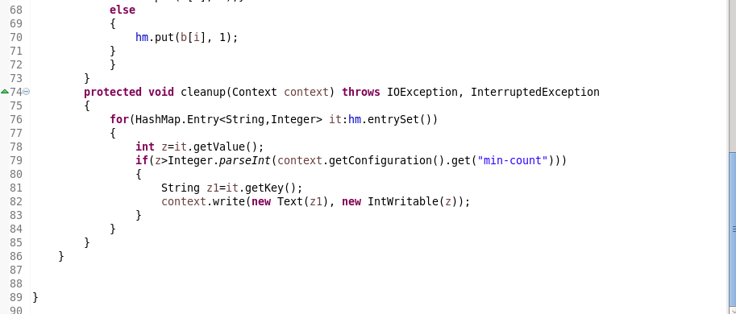

**INPUT FILE:**

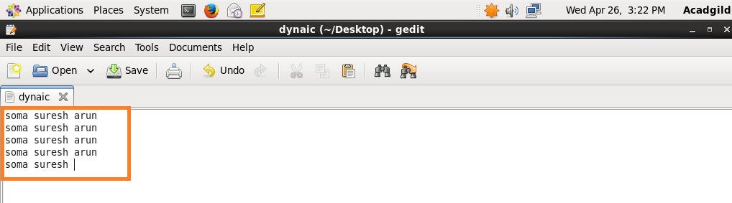

**RUNNING JAR:**

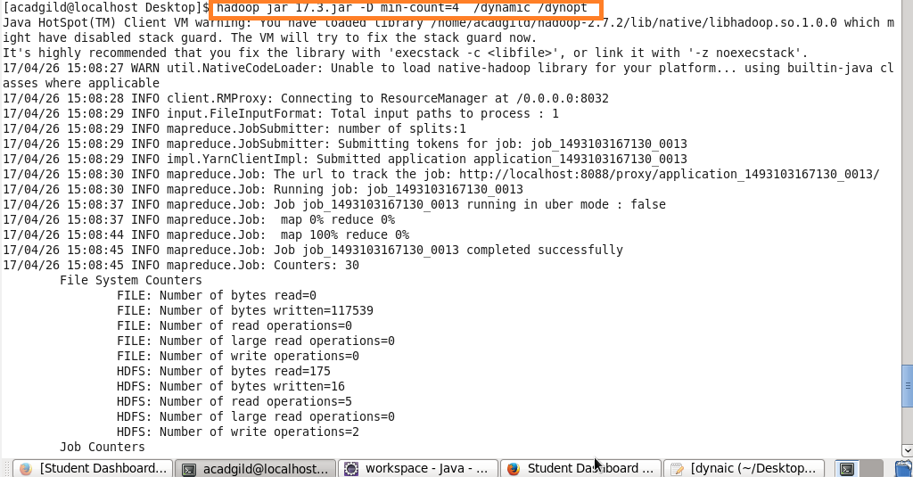

**OUTPUT:**

